EXPERIMENT – 2
Aim:
Study of the following libraries for data visualization: 1) Matplotlib Pyplot 2) Seaborn Library
Theory:
Python, libraries like Matplotlib and Seaborn are widely used for data visualization because they make it easier to understand patterns and trends in data. Matplotlib is a low-level plotting library that provides great control over creating basic graphs such as line plots, bar charts, histograms, and scatter plots, making it highly customizable but sometimes more complex to use. On the other hand, Seaborn is built on top of Matplotlib and offers a higher-level interface with more attractive and informative statistical graphics, such as heatmaps, box plots, and pair plots, with less code. Seaborn also integrates well with data structures like pandas DataFrames and automatically applies better styling and color themes, making visualizations more appealing and easier to interpret. Together, these libraries help users analyze data effectively and present it in a clear and visually engaging way.
MATPLOTLIB PYPLOT:
Matplotlib's pyplot module is a widely used interface that simplifies the process of creating visualizations in Python. It provides a MATLAB-like syntax, allowing users to generate line charts, bar graphs, scatter plots and other common visualizations with ease. With just a few lines of code analysts and developers can turn raw data into clear, informative charts for analysis and presentation. Matplotlib is a low-level graph plotting library in python that serves as a visualization utility. Matplotlib was created by John D. Hunter. Matplotlib is open source and we can use it freely. Matplotlib is mostly written in python, a few segments are written in C, and JavaScript for Platform compatibility.
Importing Matplotlib and Checking Version:

Basic Plotting with Pyplot
Below are some of the most commonly used chart types in Pyplot, each demonstrated with a short example.
1. Line Plot
Line plots are simplest types of charts. The plot() function takes two lists: one for x-axis and one for y-axis and connects the points in a linear path.
Example:
Following code uses plt.plot() to draw a basic line graph for the given x and y values using Pyplot module.
import matplotlib.pyplot as plt
x=[1, 2, 3, 4]
y=[1, 4, 9, 16]
plt.plot(x,y)
plt.show()
Output
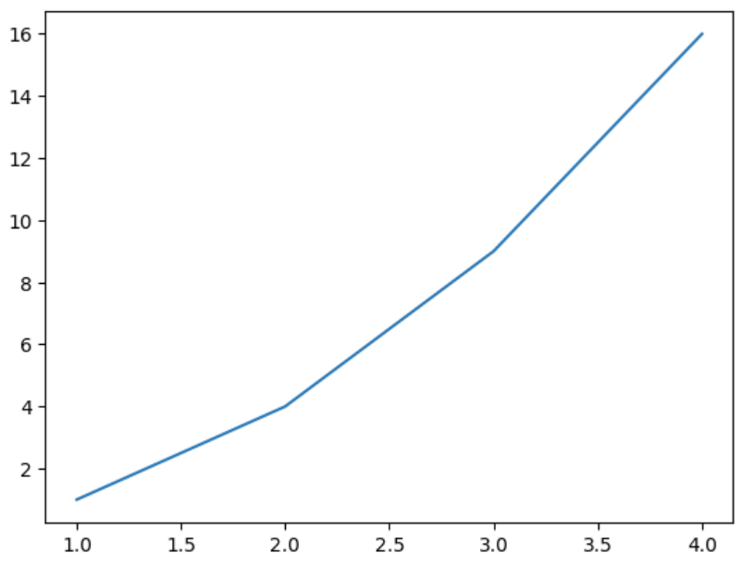Plotting a line graph using pyplot
Explanation:
- plt.plot(x, y): creates a line plot by connecting x and y data points.
- plt.show(): displays final plot window.
2. Pie Charts
Pie charts show the share of each category in a whole. The pie() function takes a list of values and optional labels to represent each slice of the pie.
Example:
This code creates a pie chart using plt.pie() function to visualize the percentage share of different programming languages.
import matplotlib.pyplot as plt
labels = ['Python', 'Java', 'C++', 'JavaScript']
sizes = [40, 30, 20, 10]
plt.pie(sizes, labels=labels, autopct='%1.1f%%')
plt.show()
Output
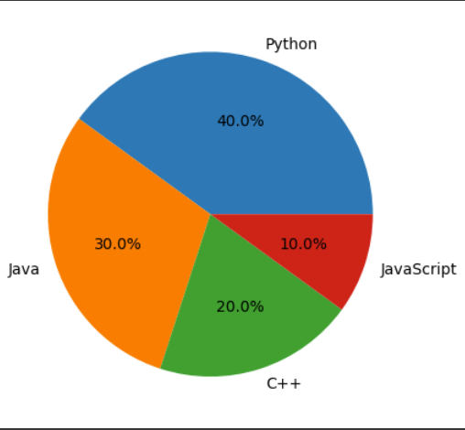Pie chart using pyplot
Explanation: plt.pie(sizes, labels=labels, autopct='%1.1f%%') creates a pie chart with slice sizes from sizes, labels for each slice and autopct shows percentage values with one decimal place.
3. Bar Charts
Bar charts are ideal for comparing quantities across categories. The bar() function takes two lists one for category labels (x-axis) and one for their corresponding values (y-axis).
Example:
This Example creates a bar chart using bar() function to display values for different categories.
import matplotlib.pyplot as plt
categories = ['A', 'B', 'C', 'D']
values = [3, 7, 2, 5]
plt.bar(categories, values)
plt.show()

Output
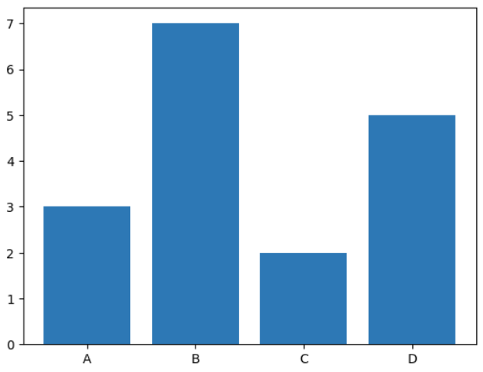Bar Chart using Pyplot
Explanation: plt.bar(categories, values) draws a vertical bar chart using given categories and values.
4. Scatter Plots
Scatter plots are used for displaying individual data points and showing relationship between two variables. The scatter() function takes two lists like plot(), but it only plots the individual points without connecting them.
Example:
Here, scatter plot is plotted using scatter() function to visualize individual data points.
import matplotlib.pyplot as plt
x = [1, 2, 3, 4, 5]
y = [5, 7, 9, 11, 13]
plt.scatter(x, y)
plt.show()
Output
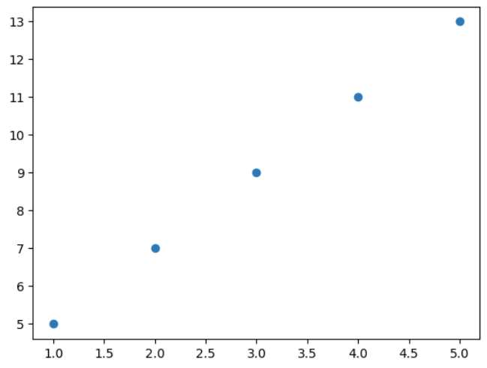Scatter Plot using Pyplot
Explanation: plt.scatter(x, y) plots individual data points as dots at specified (x, y) coordinates.
5. Histograms
Histograms are used to visualize distribution of a dataset. The hist() function takes a list or array of numerical data and divides it into bins.
Example:
A histogram is plotted using hist() function to visualize the distribution of 1000 random data points.
import matplotlib.pyplot as plt
import numpy as np
data = np.random.randn(1000)
plt.hist(data, bins=30)
plt.show()
Output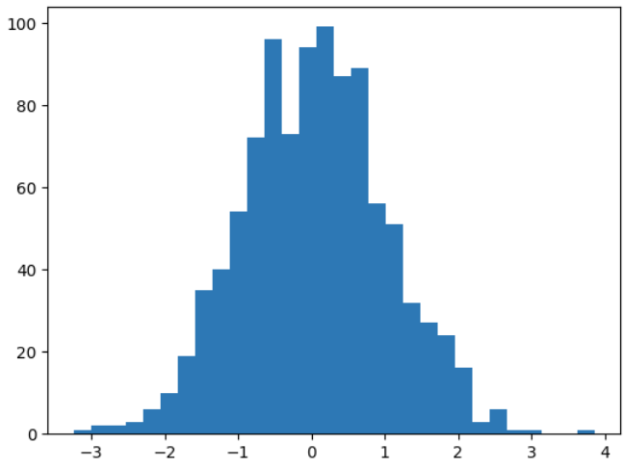
Histogram Using Pyplot
Explanation:
- np.random.randn(1000): generates 1000 random numbers from a standard normal distribution.
- plt.hist(data, bins=30): creates a histogram of the data with 30 bins (intervals).
……………………………………………………………………………………………………………………
SEABORN LIBRARY:
Seaborn is a Python library for creating statistical visualizations. It provides clean default styles and color palettes, making plots more attractive and easier to read. Seaborn is a Python library built on top of Matplotlib that focuses on statistical data visualization. It provides high-level functions, built-in themes, and automatic handling of datasets, allowing users to create informative and visually appealing plots with minimal code. Seaborn is widely used for exploring trends, relationships and distributions in data.
Basic Plots in Seaborn:
- Lineplot: Lineplot is used to show the relationship between two continuous variables. It is commonly used for time-series or ordered data.
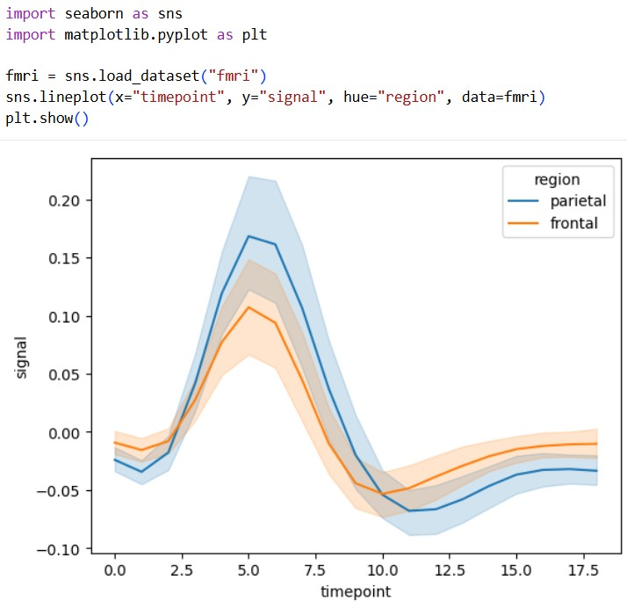

- Boxplot: Boxplot is used to show the distribution of data based on quartiles. It helps identify spread and outliers.
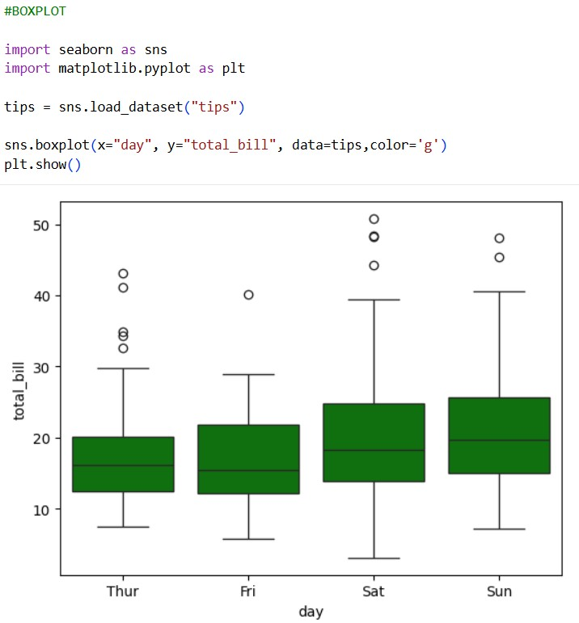

- HeatMap: Heatmap is used to visualize matrix-like data using colors. Displays data values using color gradients, ideal for correlation.

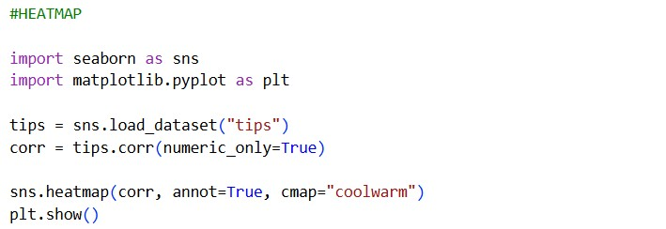

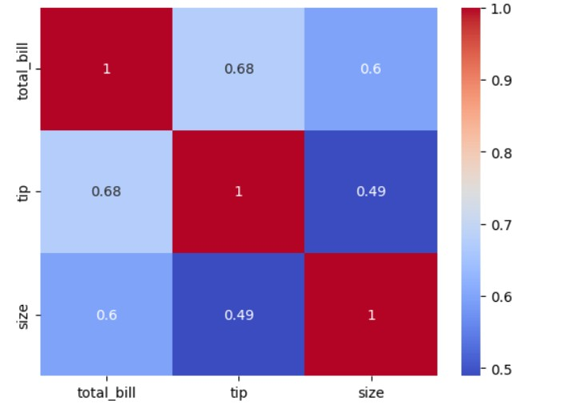

- Scatter Plot: Scatterplot is used to show the relationship between two numerical variables. It helps in identifying patterns or correlations.

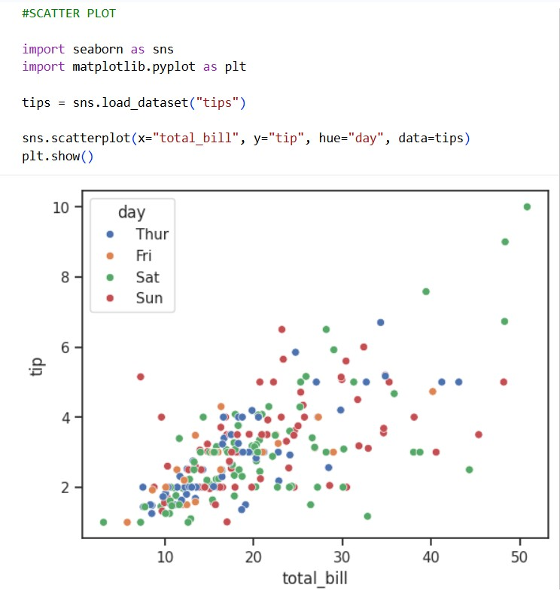

- Pair Plot: Pairplot is used to plot pairwise relationships between multiple numerical variables. It shows Pairwise relationships in dataset.

